# A Project Report on

Fake news analysis in social media using IBM

Submitted to Smart Bridge

By:

Rajesh Kolusu 18481A0243

Revanth Kolluri 18481A0242

Rohith Komaravolu 18481A0244

Shiva Reddy Kolagattla 18481A0240

Varunjosh Kodamanchili 18481A0239



Under the guidance of Mr. Rammohan

Lead – Artiﬁcial Intelligence at Smart Bridge Educational Services Pvt. Ltd

Table of Contents:

|  |  |  |
| --- | --- | --- |
| **S**  **No** | **TOPIC** | **PAGE No** |
| **1** | **ABSTRACT** | **3** |
| **2** | **INTRODUCTION** | **4** |
| **3** | **LITERATURE SURVEY** | **5** |
| **4** | **SIGNIFICANCE** | **5** |
| **5** | **PROJECT FLOW** | **6** |
| **6** | **LIBRARIES** | **7** |
| **7** | **DATA SET** | **8** |
| **8** | **MODEL BUILDING** | **9** |
| **9** | **APPLICATION FLOW CHART** | **10** |
| **10** | **RESULT** | **11** |
| **11** | **CONCLUSION** | **13** |
| **12** | **REFERENCES** | **14** |

# **Abstract:**

Due to the exponential growth of information online, it is becoming impossible to decipher the true from the false. Thus, this leads to the problem of fake news. This research considers previous and current methods for fake news detection in textual formats while detailing how and why fake news exists in the first place. This paper includes a discussion on Linguistic Cue and Network Analysis approaches, and proposes a three-part method using Naïve Bayes Classifier, Support Vector Machines, and Semantic Analysis as an accurate way to detect fake news on social media.

# **Introduction:**

How much of what we read on social media and on supposedly “credible” news sites is trustworthy? It is extremely easy for anyone to post what they desire and although that can be acceptable, there is the notion of taking it a step too far, such as posting false information online in order to cause a panic, using lies to manipulate another person’s decision, or essentially anything else that can have lasting repercussions. There is so much information online that it is becoming impossible to decipher the true from the false. Thus, this leads to the problem of fake news*.*

# **Literature Survey**:

What is fake news? Fake news is the deliberate spread of misinformation via traditional news media or via social media. False information spreads extraordinarily fast. This is demonstrated by the fact that, when one fake news site is taken down, another will promptly take its place. In addition, fake news can become indistinguishable from accurate reporting since it spreads so fast. People can download articles from sites, share the information, re-share from others and by the end of the day the false information has gone so far from its original site that it becomes indistinguishable from real news .

# **Significance :**

# Using social media as a medium for news updates is a double-edged sword. On one hand, social media provides for easy access, little to no cost, and the spread of information at an impressive rate. However, on the other hand, social media provides the ideal place for the creation and spread of fake news. Fake news can become extremely influential and has the ability to spread exceedingly fast. With the increase of people using social media, they are being exposed to new information and stories every day. Misinformation can be difficult to correct and may have lasting implications. For example, people can base their reasoning on what they are exposed to either intentionally or subconsciously, and if the information they are viewing is not accurate, then they are establishing their logic on lies. In addition, since false information is able to spread so fast, not only does it have the ability to harm people, but it can also be detrimental to huge corporations and even the stock market.

.

### **Project Flow :**

* User interacts with the UI (User Interface) to give the review  as input
* Given Review is  analyzed by the model which is integrated to UI build
* Once model analyses the review the prediction is showcased on the UI

To accomplish this, we have to complete all the activities and tasks listed below

* Install required packages and libraries.
* Install packages and libraries.
* Install Anaconda software.
* Run Jupyter
* Understanding the data.
* Download the dataset.
* Importing the required libraries.
* Loading the dataset.
* Countvectorizer for text classification.
* TF-IDF Vectorizer for text classification.
* Inspecting the vectors.
* Model Building
  + Splitting the data into train and test.
  + Training and testing the model with Countvectorizer & Predicting the result.
  + Training and testing the model with TF-IDF Vectorizer & Predicting the result.
  + Improving the model.
  + Inspecting the model.
  + Saving the model
* Application Building
  + Flask Structure
  + Importing libraries
  + Load Flask and Assign the model.
  + Routing to the Html page.
  + Run the app in local browser.
* Final UI
  + Input the URL & get the result.

**LIBRARIES :**

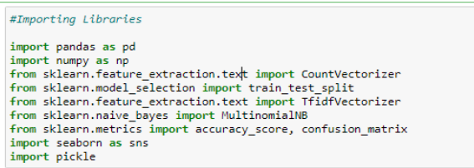

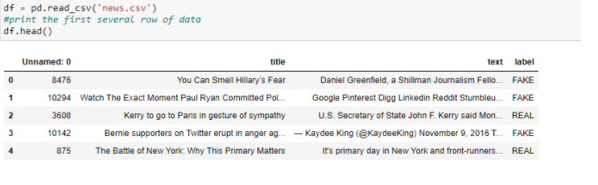

**DATA SET:**

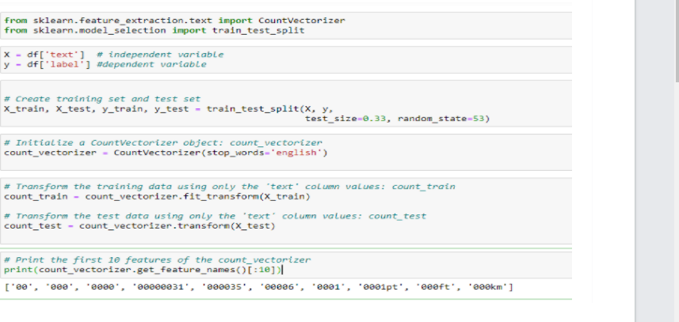

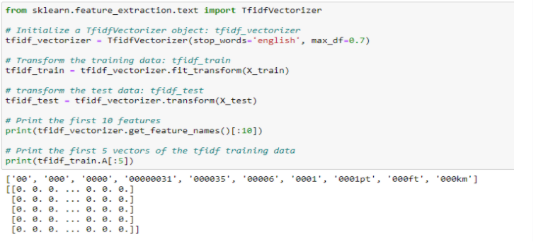

**MODEL BUILDING:**

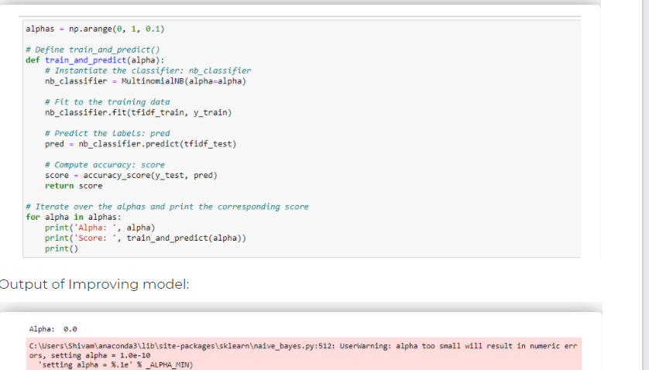

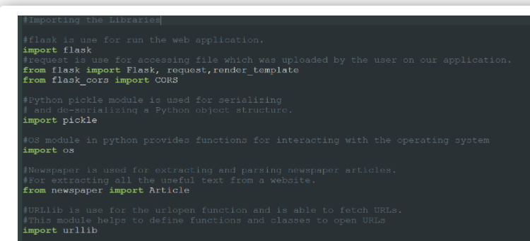

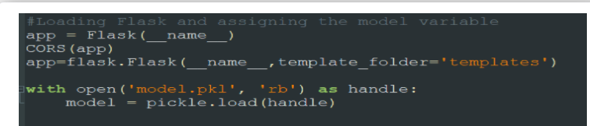

**Flow Chart:**

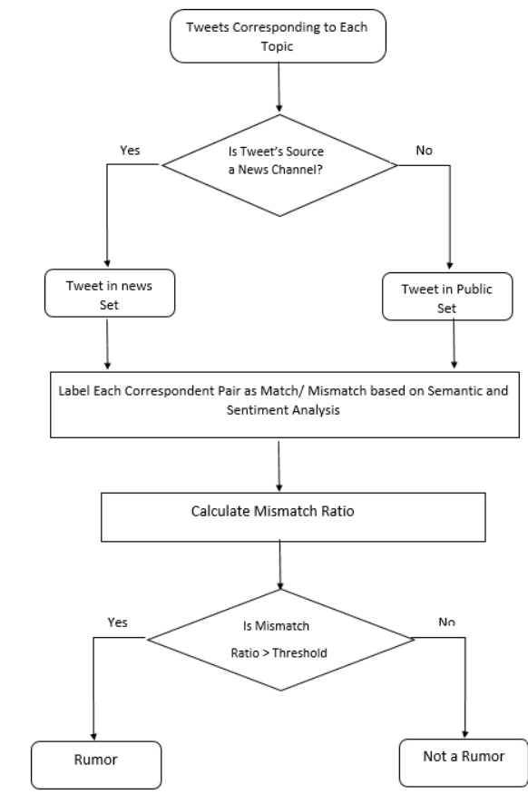

Results:

Input:

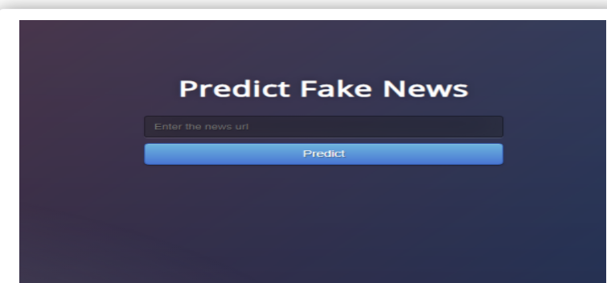

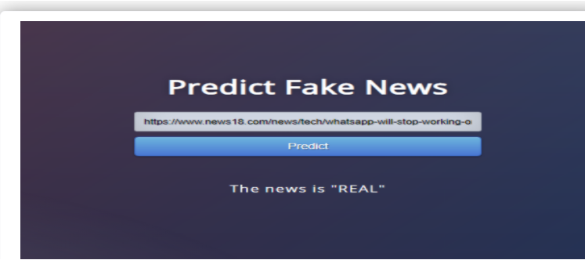

Output:

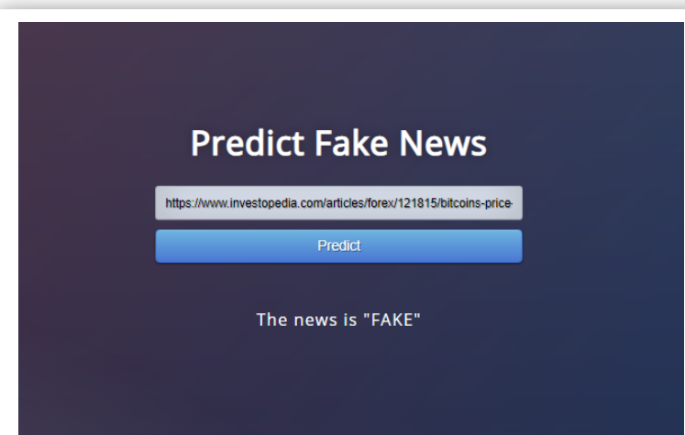

# **Conclusion:**

As mentioned earlier, the concept of deception detection in social media is particularly new and there is ongoing research in hopes that scholars can find more accurate ways to detect false information in this booming, fake-news-infested domain. For this reason, this research may be used to help other researchers discover which combination of methods should be used in order to accurately detect fake news in social media. The proposed method described in this paper is an idea for a more accurate fake news detection algorithm. In the future, I wish to test out the proposed method of Naïve Bayes classifier, SVM, and semantic analysis, but, due to limited knowledge and time, this will be a project for the future.

It is important that we have some mechanism for detecting fake news, or at the very least, an awareness that not everything we read on social media may be true, so we always need to be thinking critically. This way we can help people make more informed decisions and they will not be fooled into thinking what others want to manipulate them into believing.

**REFERENCES:**

Brambrick, Aylien, N. (n.d.). KDnuggets. Retrieved February 20, 2018, from [https://www.kdnuggets.com/2016/07/support-vector-](https://www.kdnuggets.com/2016/07/support-vector-machines-simple-explanation.html) [machines-simple-explanation.html](https://www.kdnuggets.com/2016/07/support-vector-machines-simple-explanation.html)

Chen, Y., Conroy, N., & Rubin, V. (2015). News in an online world: The need for an “automatic crap detector”. *Proceedings of the Association for Information Science and Technology*, *52*(1), 1-4.

Conroy, N., Rubin, V., & Chen, Y. (2015). Automatic deception detection: Methods for finding fake news. *Proceedings of the Association for Information Science and Technology*, *52*(1), 1-4.

Fan, C.